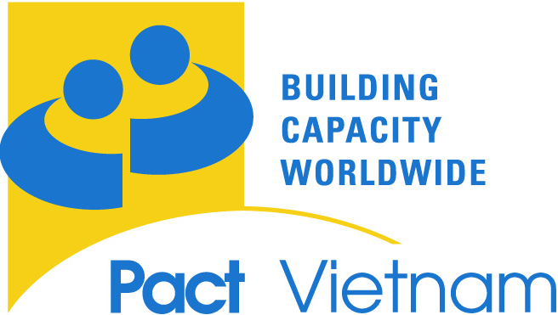

Training Registration Form

Training for civil sOCIETY ORGANIZATIONS
IN

PREPARATION of Expressions of Interest
FOR THE Role of Sub-RECIPENT
in THE COMMUNITY SYSTEMS STRENGTHENING COMPONENT OF VIETNAM’s Global Fund Round 9 SUBMISSION

Organized By Pact Vietnam and UNAIDS

Organizational Information:

Name of Organization:
Address:
District/Province:
Name of Contact Person:
Position/Title:
Phone:
Fax:
E-mail address:

Please indicate type of organization (please select one only):
International NGO
International Educational Institution
International Faith-Based Organization (FBO)
Local NGO
Local Educational Institution
Local Faith-Based Organization (FBO)
Local Community Based Organization (CBO)
Self Help Group
Association
Mass Organization
Other

Please Explain_______________________________________________________

Is your organization legally registered in Vietnam?

Province/s and District/s in which you are currently operating:

Is your organization planning to apply as part of a consortium? Yes No

If yes, which organizations are the other members?

If yes, are you the lead applicant under this consortium?

If not, which consortium member will play this role, if known?

Programmatic Experience to Date in Viet Nam:

Does your organization have HIV/AIDS programming experience in Vietnam?

If yes, how may years of HIV/AIDS programming experience in Vietnam does your organization have?

Experience working in HIV-related programming in Viet Nam:
Program / Project Name | Year(s) | Target Population and Geographic Coverage | Project Purpose | Funder/ donor | Total Funding in USD

Other donor-funded programming experience not listed above (maximum 3):
Program / Project Name | Year(s) | Target Population and Geographic Coverage | Project Purpose | Funder/ donor | Total Funding in USD

Workshop Participation

Participants

Name of Individual(s) who will attend the training (2 maximum) | Position in the Organization | Will this person develop your organization’s EOI or participate in the development of another organization’s EOI as a consortium member? (Yes or No)

Venue and Time:

Please tell us your preferred training location and dates, marking X against the trainings which you would be able to attend and indicating your preferred training in the final column.

We will do our best to accommodate your preference but may have to move participants’ dates where certain workshops are oversubscribed.

Location | Date | Availability | Preference
HaNoi | 20-21 Oct 2008
HaNoi | 28-29 Oct 2008
Ho Chi Minh City | 23-24 Oct 2008

Commitment to Confidentiality

This workshop will be held during an open procurement process with the Global Fund. Participants in the workshop will be competing with each other for funding under the Round 9 Community Systems Strengthening Component. The facilitators will introduce fictitious cases that the participants will work on to apply the concepts learned. Participants will have the choice to bring their own preliminary concepts and ideas, and to work on them – independently – during the workshop. However, they should note that Pact Vietnam will not provide direct input into any organization’s or consortium’s own EOI. In addition participants are asked to respect the confidential nature of their own and other participants’ concepts and proposal contents and are discouraged from discussing their own ideas out with their organization or consortium during the workshop.

‘I agree that all materials my organization brings to the workshop are fully our own responsibility and we will make a special effort to safeguard them’. Yes No

Signed Position in Organization:

